**Name: Salma Abdel Monem Abdel Motaleb**

**Assignment Two – Week3**

1. Train/dev/test sets

Train data set : used for setting the weights and biases.

Development/Evaluation set: used for tuning the hyperparameters

Test set: provides unbiased evaluation of the final model

1. Bias and Variance

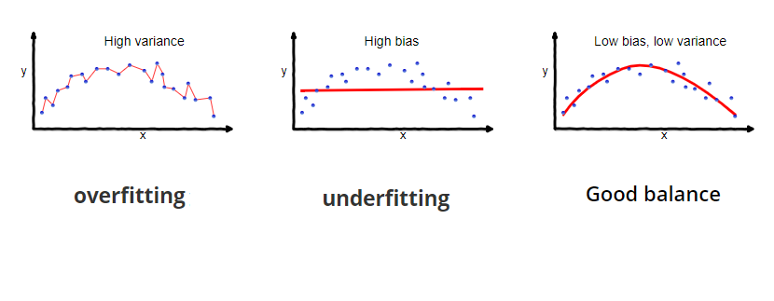

Methods to reduce the Bias:

-use the right learning model.

-use more representative dataset

Methods to reduce the Variance:

- increase the dataset size.

- use regularization techniques.

1. Regularization

Cost function

$$J\left(W,b\right)=\frac{1}{m}\sum_{l}^{L}{l({y^{^}}^{i}-y^{i}})+\frac{λ}{2m}\sum_{l}^{L}{{\left\|W^{l}\right\|}^{2}}$$

Back Propagation

$${dw}^{L}={dw}^{L}old+\frac{λ}{m}W^{L}$$

Learning

$$W^{L}=W^{L}-α{dw}^{L}$$

$$W^{L}=W^{L}-α{dw}^{L}old-α\frac{λ}{m}W^{L}$$

$$W^{L}={(1-α\frac{λ}{m})W}^{L}-α{dw}^{L}old$$

1. Normalization

The goal is to keep the scale of the input dataset as close as possible so that every point is of equal importance.

This also helps the gradient descent to work faster.

1. Weights initialization

Initialize W to random * 2/nx

1. Checks for gradient descent

Used for debugging the backpropagation